KARAGEM Doorknob sanitizer Price List
*Karagem Doorknob Sanitizer

Product Image | Product | Origin | MSRP | Order QTY | FOB Distributor  Price | Production  Lead Time
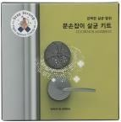 | Karagem Doorknob Sanitizer Kit | Made in Korea HS Code:  3307-49-0000 | U$19.99 | 5,000~20,000 | U$7.60 | 3 Days
 |  |  |  | 20,000~36,000 | U$7.30 | 7~20 Days
 |  |  |  | 36,000 ~ | U$7.10 | 7~20 Days
Product Image | Product | Origin | MSRP | Order QTY | FOB Distributor  Price | Production  Lead Time
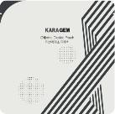 | CLO2 Pouch (Refill) | Made in Korea | U$10.00 | 10,000 | U$4.50 | 3~10 Days

Packing information

Input QTY | Weight | SIZE(CBM) | Dimension | 1/Pallet | 20“ Container | 40“ Container
60 pcs | 3kg | 0.03CBM | 46*30.5*21CM | 30 BOX | 600 BOX (36000EA) | 1200 BOX (72000EA)

Made in R.O.KOREA

*Remark: Production Leading Time will be changed on subject’s production.

